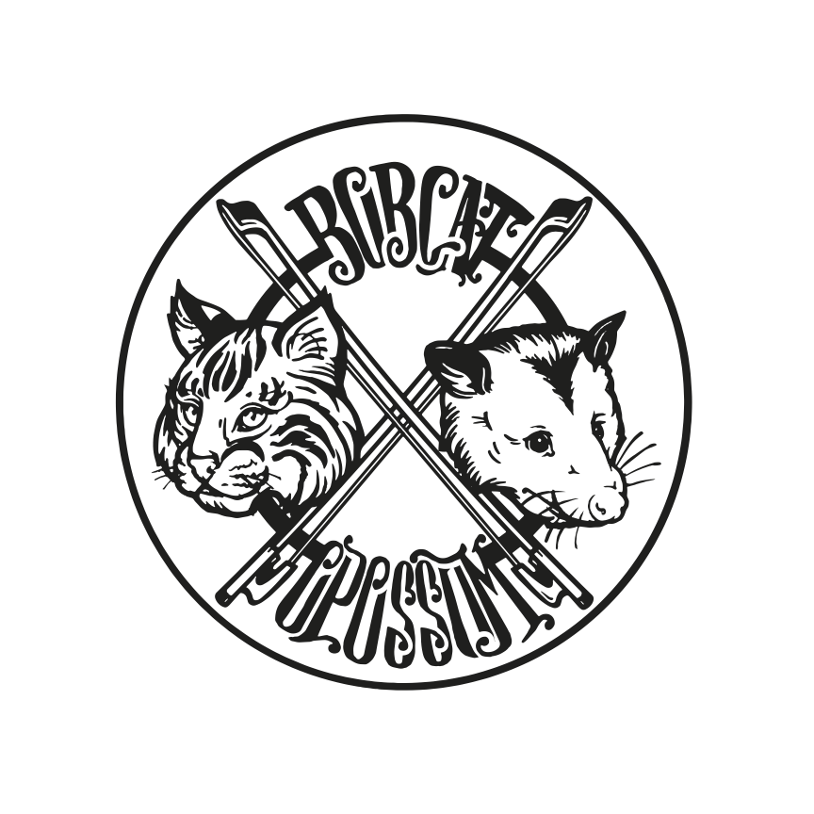
Bobcat Opossum Rider

THIS IS THE WAY WE SEE IT:

You have a great venue and we will bring great music to it. You have an audience base, Bobcat Opossum has dedicated fans, and we all want to attract new folks to an event that everyone will enjoy and rave about to other music lovers! We have a lot in common already!

We are dedicated, good-humored, professional musicians and we will work hard to put on an entertaining performance with your support. While we can be flexible, if any items listed below are not available or need to be renegotiated, please contact our tour manager, Ellen Coplin as soon as possible - preferably at least one month in advance as arrangements are made well in advance of the show. If no contact is made, we will assume this rider will be fulfilled to specification.

BAND CONTACT:

Manager: Sean Hoffman Phone: 574 354 1987 Email: bobcatopossum@gmail.com

Tour Manager: Ellen Coplin Phone: 260 414 9670 Email: bobcatopossum@gmail.com

PERFORMANCE FEE AGREED UPON FOR THIS EVENT:

- Balance of performance fee is due at the time of or immediately following the performance. If payment is not fulfilled on the night of the show without prior agreement, Bobcat Opossum reserves the right to charge and extra 10% late fee for every week that payment is tardy.
- Payment shall be made to “Sean Hoffman” (Settle with Sean Hoffman)

OPENING ACT: (If used or necessary) Must be approved by BOBCAT OPOSSUM

PARKING: Band vehicle (midsize SUV) parking will be provided by THE CLIENT/VENUE at no cost to BOBCAT OPOSSUM and should be located within a reasonable distance to the venue, preferably adjacent to venue.

THE CLIENT/VENUE will provide timely instructions as to time and location of load-in and provide assistance for ease of load-in. Sean Hoffman will be in contact a couple weeks before the show to confirm the load-in time and other details. Please respond promptly to his emails.

OVERNIGHT ACCOMMODATIONS:
THE CLIENT/VENUE will reserve one (1) single hotel room (preferred) on the night of the performance/s. Reasonable alternative arrangements will be considered with advance notice, preferably a month, by Ellen Coplin. No couches, sofa beds, or air mattresses.

HOSPITALITY:
• DRESSING ROOM: THE CLIENT/VENUE will provide a secure and private dressing room for the band for use prior to and following the performance. Before, during, and after the performance, THE CLIENT/VENUE will take reasonable precautions for the safety of Bobcat Opossum’s band members and crew, equipment, instruments and personal belongings.

• MEAL: One meal each for two (2) members of the band. Preferred are healthy gluten-free (choice, not allergy) food options/ menus that aren’t heavy on fried items and dairy. Thai, Mexican, Mediterranean, and Vietnamese are some favorites. If it is not possible to arrange for such a meal, a buyout of $20 per band/crew member is acceptable ($40). Please give prior notice to the tour manager if a meal will not be available at the venue.

• GREEN ROOM: Filtered fresh water, coffee, hot herbal tea (throat coat, rooibos, or peppermint if available ), honey, fresh fruit and veggies, tortilla chips/salsa, fruit juice (cranberry, pomegranate or lemon), sparkling water, kombucha, Bourbon (Bulleit Rye or other rye), and a bottle of dry red wine (cabernet, shiraz, or pinot noir).

*Water: Please provide plenty of room temperature water, minimum 4 bottles, and cold water in the dressing room.

TECHNICAL REQUIREMENTS:
• THE CLIENT/VENUE will provide a sound tech(s) who will run sound for FOH and monitors during the show unless other arrangements are made in advance.

• THE CLIENT/VENUE will have a professional sound system that meets the requirements of BOBCAT OPOSSUM stage plot/tech rider and will provide sufficient stage lighting. All mic stands will be provided by THE CLIENT/ VENUE. See stage plot/tech rider for requirements.

• SOUND CHECK will occur prior to the opening of the house and no less than two (2) hours prior to performance time. Three (3) hours before doors is the preferred load-in/sound check time.

* We want to thank the tech crew and house crew in advance for working with us to make the show the best it can be. We look forward to working with you, and we appreciate your craft and talents.

ADVERTISING & PUBLICITY:
Billing on ALL advertising and media publicity, as well as venue marquee/
signage must appear as follows: BOBCAT OPOSSUM. Do not grab photos from Facebook, website, or other online sources without prior permission and approval. BOBCAT OPOSSUM has photos, videos and other press items available for you to use... and to make your life easier.
Please contact Ellen Coplin to request any materials you may need.

TICKETS & MERCHANDISE:
THE CLIENT/VENUE agrees to give out no more than 2% of the house in complimentary tickets without prior written consent. When appropriate, THE CLIENT/VENUE will honor requests for a limited amount of comps, 2 per band member, 6 preferred.

BOBCAT OPOSSUM have the sole right to sell/authorize sale of band-related merchandise at a prominent location in the venue, for which THE CLIENT/VENUE will provide a table. THE CLIENT/ VENUE will arrange for volunteer staffing (1-2 people) at the sales table. If staffing can not be provided THE CLIENT/VENUE must contact Ellen Coplin in advance.

LEGALITIES:
*THE CLIENT/VENUE warrants and represents that it has, or shall obtain, sufficient personal injury and property damage liability insurance with respect to the activities of Bobcat Opossum at the place of performance.

*Deposits are nonrefundable. If THE CLIENT/VENUE cancels the show less than four (4) weeks before the date of performance, Bobcat Opossum shall be paid the identified balance as liquidated damages. THE CLIENT/VENUE must provide written notice of the cancellation. If the cancellation is weather related, THE CLIENT/VENUE and BOBCAT OPOSSUM will work to find
a suitable replacement date. *The obligation of BOBCAT OPOSSUM to perform shall be excused due to sickness, accidents, riots, strikes, epidemics, acts of God, Force Majure or any other legitimate condition beyond the control of BOBCAT OPOSSUM. BOBCAT OPOSSUM wants to play your show and will do everything in their power to make that happen or to reschedule in the unfortunate event of the scenarios mentioned above.

*For any dispute arising out of this contract rider, the parties agree that the jurisdiction shall be Kosciusko County, IN (With mutual respect and fairness, it never needs to come to that!)

Please review, confirm or give changes and reply by email. We MUST have a reply so that we are all on the same terms and understanding. No paper is needed for this contract rider. Thank you.

